58 / Optometry
Iridological Analysis as a Complement to Anterior Segment Diagnostics?


MONIKA LUŻYŃSKA
Foto: archiwum Autorki
Optician PNO13665, optometrist
NO16113 iridologist, journeyman
Naturopath
KRZYSZTOF KWELA

Surgeon, urologist, iridologist
Foto: archiwum Autora

As an optometrist and iridologist, I observe with great interest and satisfaction the growing attention being paid to iridology by vision care specialists. Outside Poland, iridology is widely recognized and respected as a diagnostic method [1]. The discipline has existed for over 150 years [2] and involves assessing an individual’s health status based on analysis of the iris appearance [2,3]. Unfortunately, in Poland it is still often associated with fortune-telling and superstition, a perception I find deeply regrettable.
Iridologists acquire their knowledge through specialized training courses, which are also available in Poland (physical iridology). In other countries, it is possible to study behavioral, clinical, and so-called integrated iridology - the latter combining knowledge from all individual branches [4,1]. Iridology as a discipline constitutes a part of naturopathy [1]. Thus, obtaining a comprehensive foundation in naturopathic medicine is desirable, typically through two-year programs culminating in a professional examination. Professional qualifications may also be formally recognized through the Guild.
I often compare iridology to autorefractometry - a quick and painless test that provides general information about the visual system but still requires refinement by a specialist using a trial frame and/or a phoropter. Similarly, iridology can reveal multiple indicators of general health; however, these findings should be confirmed through laboratory investigations and other specialized examinations [2,3].
By observing the anterior segment of the eye, including the iris, it is possible to analyze and interpret various signs, thereby supporting patients in managing their health. Moreover, the identification of so-called warning signs may prompt patients to undergo preventive examinations that can, in some cases, be lifesaving [2,3].
As an illustration, I present the case of my patient/client who, as a part of a preventive eye examination, reported ongoing thyroid problems (suspected but unconfirmed Hashimoto's disease). Her visual acuity was within normal limits (uncorrected visual acuity, Vis s.c. 1.0). While I was observing the iris during the examination, my attention was drawn to signs in the regions corresponding to the ovarian zone and the aforementioned thyroid zone. As the patient expressed a desire to gain further insight into her health predispositions, I proceeded to perform an iridological analysis.
Iridological analysis:

Female, 32
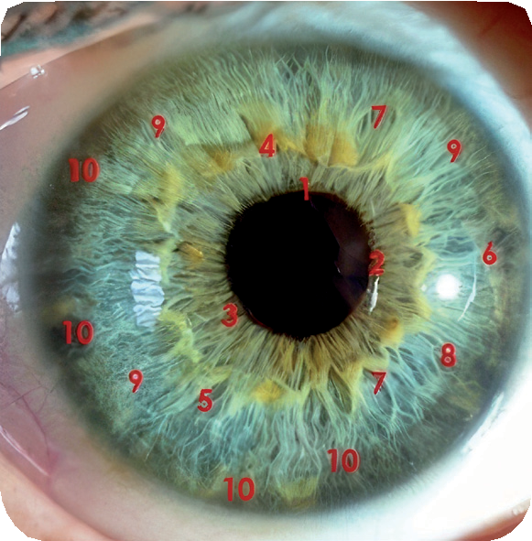
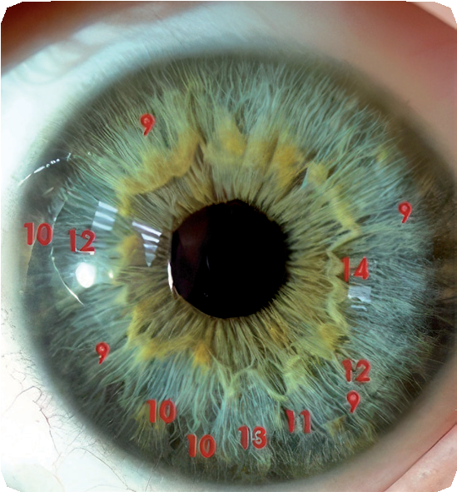
Photo 01. Right eye iris (OD) Photo 02. Left eye iris (OS)

• Structure: II.
• Constitution: lymphatic
• Subtype: hydrogenoid with neurogenic elements
1. Pupil: round, flattening at 12 o'clock OD, displaced to the right.
2. Collarette: visible, granular.
3. Pupillary zone: slight brightening of the gastric zone.
4. Pigment ruff, irregular, almost square.
5. Analysis of the ciliary zone primarily revealed: OD — forming asparagus lacuna in the ovarian zone.
6. Rarefaction of fibers in the thyroid zone.
7. Lacuna in the pancreatic zone + pancreatic pigment.
8. Rarefaction of fibers in the zone: upper back.
9. Double ruff and rarefaction of fibers in the cardiac zone, contraction rings.
10. Lymphatic rosary, indicating weakening of the lymphatic system.
11. OS: deep crypt in the ovarian zone.
12. Weakening of the pancreas and thyroid zone.
13. Rarefaction of fibres: renal zone. [1,2,3,4,5,6].
OPTYKA 2(93)2025
Optometry / 59

Recommendations for iridological analysis:

Typical for hydrogenoid subtype: reduce milk, sugar, fruit, and alcohol intake; undergo gynecological checkup as well as gastric and duodenal assessment if warranted by concerning symptoms; undergo thyroid assessment; start regular blood glucose monitoring after the age of 50; take care of spinal health and lymphatic system status; plan whole-body detoxification; make sure adequate stress-management strategies are in place[1,2,4].

Case study
During a routine gynecological appointment, cystic lesions of the left adnexa were revealed upon examination, including transvaginal ultrasound. Surgical intervention was recommended by consulting gynecologists. As the patient was asymptomatic and her serum tumor marker levels were within normal limits, she considered postponing or even forgoing surgery. She was more inclined towards pharmacologic
al treatment, hoping for pharmacotherapy-induced resorption of the lesions.

However, considering the iridological findings, which revealed deep crypts in the ovarian zone [2,4,5,6], I recommended proceeding with surgery. Intraoperatively, the lesions were found to be larger than previously indicated by gynecological examination, including transvaginal ultrasound (as reported by the patient over the phone). The patient has since undergone the procedure and attended a follow-up gynecological appointment. Her current health status is very good.
Gynecological examination reports (as per patient's medical records, quoted in the original format):

Multi-phase computed tomography of the abdomen and lesser pelvis: a fluid-density lesion with dense content in the left ovary (cystic character), approximately 47×38 mm, without post-contrast enhancement evident on CT - detailed assessment possible by pelvic MRI. Additionally, a thin-walled, fluid-density lesion in the left ovary measuring approximately 30 × 40 mm was observed, most consistent with a simple cyst..

Laparoscopy: Type of surgical procedure: laparoscopy. Enucleation of a left paratubal cyst; enucleation of a left ovarian cyst. Preoperative diagnosis: left ovarian tumour. Operative report: The operating field was prepared, and pneumoperitoneum was established using a Veress needle. A single optical trocar was introduced in the periumbilical region, and three working trocars were placed suprapubically. Normally-sized uterine body was visualized, with unremarkable right adnexa. A paratubal cyst approximately 60 mm in diameter was visualized on the left side, along with a left ovarian cyst approximately 60-70 mm in diameter. No free fluid was observed in the pouch of Douglas, and the remaining abdominal and pelvic organs were unremarkable. The paratubal cyst and the left ovarian cyst were enucleated. The specimens were removed in an endobag. Haemostasis was confirmed, and irrigation was performed. Clinical diagnosis: bilateral ovarian cysts..

Macroscopic description: 1. Left ovarian cyst. Surgical specimen

weighing 20 g, consisting of a thin-walled, multilocular cyst 50 mm in diameter filled with clear fluid. 2. Left paratubal cyst. Surgical specimen weighing 10 g, consisting of an incised cyst 40 mm in diameter with a slightly thickened wall and a brown-pigmented lining. Histopathological diagnosis: left ovarian cyst, endometrial paratubal cyst of the left fallopian tube.Case discussion / surgeon’s commentary
An ovarian cyst is a lesion that develops inside the ovary, its wall, or externally to the ovary, in which case it is connected by a pedicle. Cysts are classified as functional, endometrial, or dermoid. Most adnexal cysts are benign; however, some may undergo malignant transformation. Cystectomy is recommended for cysts that are large, at risk of rupture, or suspected of malignancy, Early-stage diagnosis of ovarian cancer is, however, far from straightforward. It is well established that malignant lesions are more likely to be larger and to occur in somewhat older women - namely, those over 45 years of age. In clinical practice, however, decisions must be made on an individual basis, weighing the risks of surgery against a watchful waiting approach. Malignant ovarian tumors are the fourth leading cause of death in women.
In 2009, approximately 3,000 women were diagnosed with ovarian cancer, of whom more than 2,000 died - reflecting a very high mortality-to-incidence ratio. This is largely due to the absence of effective screening programs and the difficulty of detecting ovarian cancer at an early stage, when it can easily be mistaken for benign lesions. The most accurate diagnostic modality for ovarian cancer is PET/CT (positron emission tomography combined with computed tomography), with a sensitivity of approximately 90% for ovarian tumors. However, high cost and limited number of centers carrying out the PET/CT scans restrict their use to selected patients, resulting in a risk of delayed malignancy diagnosis in most cases. Moreover, a cyst-like lesion deemed benign at the time of examination may still undergo malignant transformation later. On the other hand, routine surgical removal of all adnexal cystic lesions detected would result in most procedures being carried out unnecessarily, thereby needlessly exposing the majority of patients to various risks, including those associated with anesthesia [7,8,9].
Conclusions
Iridological diagnostics may have a meaningful role to play in cases such as one described herein. The presence of iridological warning signs - in this case, deep crypts - in the ovarian zone should prompt the patient to seek a relatively urgent gynecological consultation and to undergo surgical gynecological treatment or close follow-up, as advised by the specialist. If this reasoning proves valid, in many cases the proposed course of action could facilitate the detection and surgical treatment of lesions before malignant transformation, as well as enable identification of very early-stage malignancies. In the presently discussed case, there is a considerable probability that development of adnexal cancer was prevented. It goes without saying that the availability of iridological diagnostics should by no means discourage patients from attending periodic preventive gynecological check-ups, as no single diagnostic method is 100% effective [2]. The main advantages of iridological diagnostics include low cost, non-invasiveness, and a likely preventive role - namely, identification of lesions that have not yet undergone malignant transformation but may do so over time if left untreated [2,6].
Summary
Iridological analysis is quick and painless [2,4]. The aim of iridology is not to frighten people but to promote prevention [2,5]. Who, if not we—eye care professionals such as ophthalmologists, optometrists, and even opticians—could incorporate iridology as an extension of our diagnostic methods, given that we look into the eyes and irises of several, or even dozens, of our patients/clients every day?
By carrying out our daily work, observing the anterior segment of the eye (including the iris), and incorporating iridology, we can support our patients in maintaining their health. By identifying so-called warning signs, we may encourage patients to undergo targeted preventive examinations, which can often be life-saving.

literature
- B. S. O’Brian. Iridology Textbook: the Core Curriculum. Iris analysis Manual. 2015
- A. Szmukała-Rostovceva. Irydologia zilustrowana. GWP Sopot 2014
- M. Woźniak. Oczy odbiciem zdrowia. Irydologia i ziołolecznictwo. Oficyna Wydawniczo-Poligraficzna „ADAM”. Warszawa 2008
- T. Miller. Integrated Iridology textbook. Ligare Book Printers Australia 2016
- M. Woźniak. Irydodiagnostyka. Wydawnictwo Tramp Radom 1990
- B. Jensen. The science and practice of Iridology. USA 1989
- M. Bidziński. Onkologia. Rak jajnika 2. Najnowsze metody leczenia. Wydawnictwo lekarskie PZWL 2023
- M. Fularz, P Adamiak, R. Czepczyński. Pozytonowa tomografia emisyjna (PET) w nowotworach złośliwych. Ginekologia
Polska 2013; 84: 720-725
9. American Cancer Society. Test for Ovarian Cancer/How is Ovarian Cancer Diagnosed? https:// www.cancer. org./
grudzień 2024

About the Authors
Monika Lużyńska – a certified optician, optometrist, iridologist, and journeyman naturopath. Member of the International Iridology Practitioners Association. For 17 years, she has co-managed a family-owned optical practice in Pińczów. In her professional practice, she combines optometry with classical, behavioral, Rayid, and integrated iridology, as well as elements of naturopathy.
Krzysztof Kwela – a medical doctor specializing in general surgery and holding a European specialization in urology. In 1999, he established the first private urology clinic in Poland in Świecie, near Bydgoszcz. In 2007, the clinic expanded its services to include aesthetic and regenerative medicine procedures, particularly those concerning intimate areas, as well as trichology. In his practice, he combines conventional academic medicine with alternative medicine, including iridology and Eastern medicine.

OPTYKA 2(93)2025

